Behaviour policy and statement of behaviour principles
Emmanuel Christian School



Approved by: | A Harris | Date: 16/09/24
Last reviewed on: | 18/08/25
Next review due by: | August 2026

Introduction
At Emmanuel Christian School we believe that every child is created in God’s image. We aim to provide a safe, loving and respectful environment where children can flourish academically, socially, and spiritually. Our approach to behaviour is rooted in our Christian ethos: we hold high expectations, but we also show forgiveness and offer fresh starts. This policy sets out clear expectations, rewards, consequences, and support systems for all pupils aged 4–16.

Aims of this Policy
This policy aims to:
- Provide clear expectations for pupils, staff and parents
- Encourage good behaviour and positive relationships
- Deal with poor behaviour fairly and consistently
- Support pupils to learn from mistakes and make better choices
- Ensure the school meets Independent School Standards and statutory guidance

Our Christian Ethos and Core Values
Our behaviour policy reflects our Christian faith. We believe that discipline is about discipleship – helping children to grow in character and responsibility. We encourage pupils to live out values of:
- Christ-centred
- Resilience
- Forgiveness
- Integrity
- Respect
- Love
- Friendship
- Kindness
- Effort
- Collaboration
- Responsibility

2. Legislation, statutory requirements and statutory guidance
This policy is based on legislation and advice from the Department for Education (DfE) on:
- Behaviour in schools: advice for headteachers and school staff 2022
- Searching, screening and confiscation: advice for schools 2022
- The Equality Act 2010
- Keeping Children Safe in Education
- Suspension and permanent exclusion from maintained schools, academies and pupil referral units in England, including pupil movement 2023
- Use of reasonable force in schools
- Supporting pupils with medical conditions at school
- Special Educational Needs and Disability (SEND) Code of Practice
In addition, this policy is based on:
- Schedule 1 of the Education (Independent School Standards) Regulations 2014; paragraph 7 outlines a school’s duty to safeguard and promote the welfare of children, paragraph 9 requires the school to have a written behaviour policy, and paragraph 10 requires the school to have an anti-bullying strategy

3. Definitions
Misbehaviour is defined as:
- Disruption in lessons, in corridors between lessons, and at break and lunchtimes
- Non-completion of classwork or homework
- Poor attitude
- Incorrect uniform and lack of correct equipment
- Being late to school and lessons
Serious misbehaviour is defined as:
- Repeated breaches of the school rules
- Any form of bullying
- Sexual violence, such as rape, assault by penetration, or sexual assault (intentional sexual touching without consent)
- Sexual harassment, meaning unwanted conduct of a sexual nature, such as:
- Sexual comments
- Sexual jokes or taunting
- Physical behaviour such as interfering with clothes
- Online sexual harassment, such as unwanted sexual comments and messages (including on social media), sharing of nude or semi-nude images and/or videos, or sharing of unwanted explicit content
- Vandalism
- Theft
- Fighting
- Smoking
- Racist, sexist, homophobic or discriminatory behaviour
- Possession of any prohibited items. These are:
- Knives or weapons
- Alcohol
- Illegal drugs
- Stolen items
- Tobacco and cigarette papers
- E-cigarettes or vapes
- Fireworks
- Pornographic images
- Any article a staff member reasonably suspects has been, or is likely to be, used to commit an offence, or to cause personal injury to, or damage to the property of, any person (including the pupil)

4. Roles and responsibilities
4.1 The governing board
The governing board is responsible for monitoring this behaviour policy’s effectiveness and holding the headteacher to account for its implementation.
4.2 The headteacher
The headteacher is responsible for:
- Reviewing and approving this behaviour policy
- Ensuring that the school environment encourages positive behaviour
- Ensuring that staff deal effectively with poor behaviour
- Monitoring how staff implement this policy to ensure rewards and sanctions are applied consistently to all groups of pupils
- Ensuring that all staff understand the behavioural expectations and the importance of maintaining them
- Providing new staff with a clear induction into the school’s behavioural culture to ensure they understand its rules and routines, and how best to support all pupils to participate fully
- Offering appropriate training in behaviour management, and the impact of special educational needs and disabilities (SEND) and mental health needs on behaviour, to any staff who require it, so they can fulfil their duties set out in this policy
- Ensuring this policy works alongside the safeguarding policy to offer pupils both sanctions and support when necessary
- Ensuring that the data from the behaviour log is reviewed regularly, to make sure that no groups of pupils are being disproportionately impacted by this policy (see section 13.1)
4.3 Teachers and staff
Staff are responsible for:
- Creating a calm and safe environment for pupils
- Establishing and maintaining clear boundaries of acceptable pupil behaviour
- Implementing the behaviour policy consistently
- Communicating the school’s expectations, routines, values and standards through teaching behaviour and in every interaction with pupils
- Modelling expected behaviour and positive relationships
- Providing a personalised approach to the specific behavioural needs of particular pupils
- Considering the impact of their own behaviour on the school culture and how they can uphold school rules and expectations
- Recording behaviour incidents promptly (see appendix 3 for a behaviour log)
- Challenging pupils to meet the school’s expectations
The senior leadership team (SLT) will support staff in responding to behaviour incidents.
4.4 Parents and carers
Parents and carers, where possible, should:
- Get to know the school’s behaviour policy and reinforce it at home where appropriate
- Support their child in adhering to the school’s behaviour policy
- Inform the school of any changes in circumstances that may affect their child’s behaviour
- Discuss any behavioural concerns with the class teacher promptly
- Take part in any pastoral work following misbehaviour (for example, attending reviews of specific behaviour interventions)
- Raise any concerns about the management of behaviour with the school directly, while continuing to work in partnership with the school
- Take part in the life of the school and its culture
The school will endeavour to build a positive relationship with parents and carers by keeping them informed about developments in their child's behaviour and the school’s policy, and working in collaboration with them to tackle behavioural issues.
4.5 Pupils
Pupils will be made aware of the following during their induction into the behaviour culture:
- The expected standard of behaviour they should be displaying at school
- That they have a duty to follow the behaviour policy
- The school’s key rules and routines
- The rewards they can earn for meeting the behaviour standards, and the consequences they will face if they don’t meet the standards
- The pastoral support that is available to them to help them meet the behaviour standards
Pupils will be supported to meet the behaviour standards and will be provided with repeated induction sessions wherever appropriate.
Pupils will be supported to develop an understanding of the school’s behaviour policy and wider culture.
Pupils will be asked to give feedback on their experience of the behaviour culture to support the evaluation, improvement and implementation of the behaviour policy.
Extra support and induction will be provided for pupils who are mid-phase arrivals.

Expectations

For Pupils
- Arrive on time and in correct uniform, ready to learn
- Listen carefully to adults and follow instructions straight away
- Work hard without disturbing others
- Move calmly and safely around school
- Treat others with kindness and respect
- Take care of property and equipment
- Hand in mobile phones each morning at reception
- Be honest and take responsibility for your own behaviour

For Staff
- Model Christian values in words and actions
- Apply the behaviour policy consistently and fairly
- Use calm, respectful and clear language
- Praise and reward positive behaviour regularly
- Deal with poor behaviour firmly but kindly
- Record incidents accurately and promptly
- Communicate clearly with parents when needed

For Parents
- Support the school rules and Christian ethos at home
- Encourage your child to behave well and try their best
- Talk positively about school in front of your child
- Work with staff to solve difficulties constructively
- Attend meetings when invited
- Celebrate your child’s successes together with the school
Whole School Information
As a school every pupil is placed into one of four houses for their time at Emmanuel Christian School. The 4 houses are:






Pupils can earn house points for their houses. House points can awarded for participation in lessons, for good work and for homework. At the end of every half term, it is announced which house has won that half term and each member of the house receives a prize. The totals from each half term get added together and the winning house for that academic year is announced at the schools summer celebration. The house will receive the house point trophy and each member will receive a prize.
At the end of the academic year, pupils can be nominated by staff for the head teachers award trophy. This trophy is presented once a year at the summer celebration. Pupils are nominated by staff for consistently showing Christ-like attitudes to their learning and their behaviour in and around school. The winning pupil receives their own trophy to take home and a £30 amazon gift card.
We also have our sports day trophy which is presented to the winning house at our annual sports day event.
All trophies are displayed outside the hall in the trophy cabinet with the colour ribbons of the winning House tied to them.
Every week at our celebration assembly, pupils can be given a special mention from members of staff. This can be given for anything that deserves a mention in front of the whole school. Staff fill out a raffle style ticket for this. During the celebration assembly, pupils are given a postcard that they take home to celebrate why they got a special mention that week. At the end of every term, all the raffle tickets are placed in a bag and drawn. The prizes include amazon gift cards and sweets.

Rewards and Positive Recognition
We believe in encouraging positive behaviour by recognising and celebrating it. Rewards may include:
- Verbal praise and encouragement
- House points for effort, kindness, or achievement
- Certificates and stickers (especially in Lower School)
- Special Mentions in assemblies
- Notes, postcards, or emails home to parents
- End-of-term prizes and annual awards such as the House Cup or Headteacher’s Award
Our aim is to build each other up (1 Thessalonians 5:11).

Consequences and Sanctions
We use a simple staged approach to poor behaviour:
1. Reminder – calm prompt about the rule or expectation
2. Warning – name recorded; clear chance to put things right
3. Consequence – playtime loss (Lower) or detention/point (Middle/Upper)
➡ Serious behaviour (bullying, aggression, swearing, unsafe behaviour, discrimination) goes straight to Senior Leaders
Sanctions are applied fairly, consistently, and always with the chance for a fresh start.

Behaviour Ladders
Behaviour ladders provide clarity and consistency. Pupils and staff know exactly what happens at each stage.

Lower School Ladder
Stage 1 – Reminder
Stage 2 – Warning
Stage 3 – Loss of part of playtime + reflection
Stage 4 – Parent meeting with class teacher/Head of Lower School
Stage 5 – Referral to SLT for serious incidents
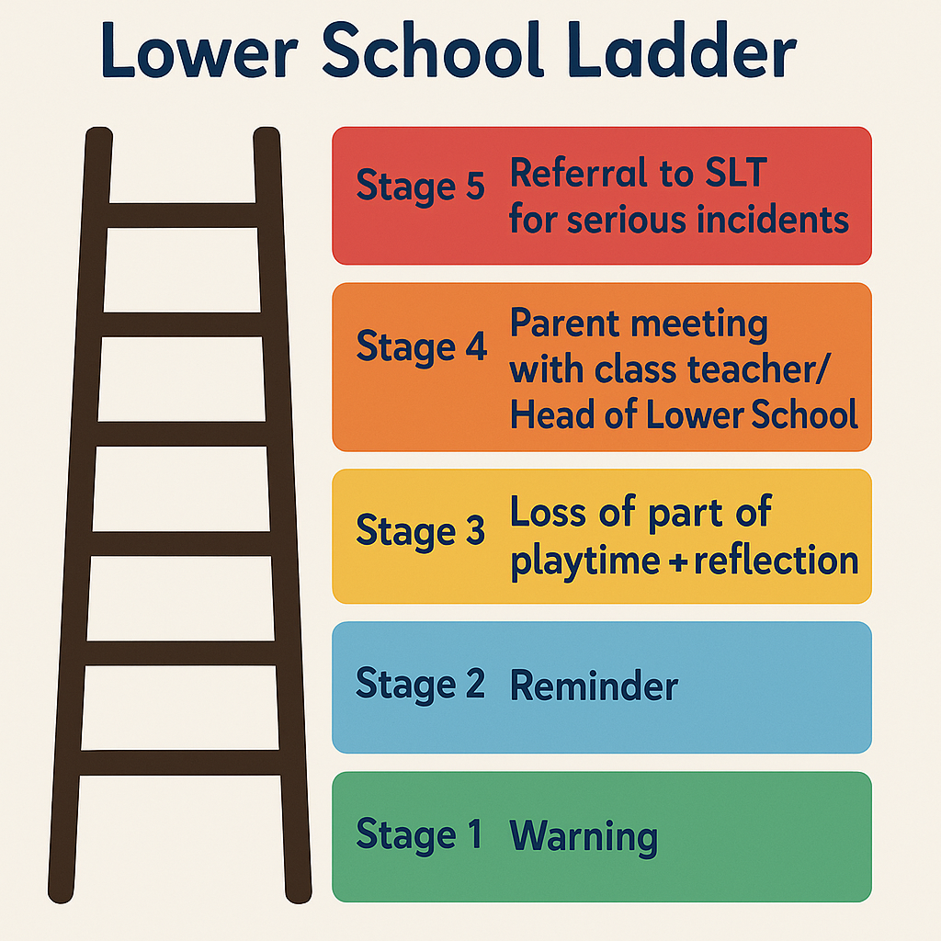

Middle & Upper School Ladder
Stage 1 – Reminder
Stage 2 – Warning
Stage 3 – Detention or behaviour point
Stage 4 – Referral to SLT and parent contact
Stage 5 – Internal Isolation
Stage 6 – Exclusion (fixed-term or permanent, for very serious or persistent behaviour)
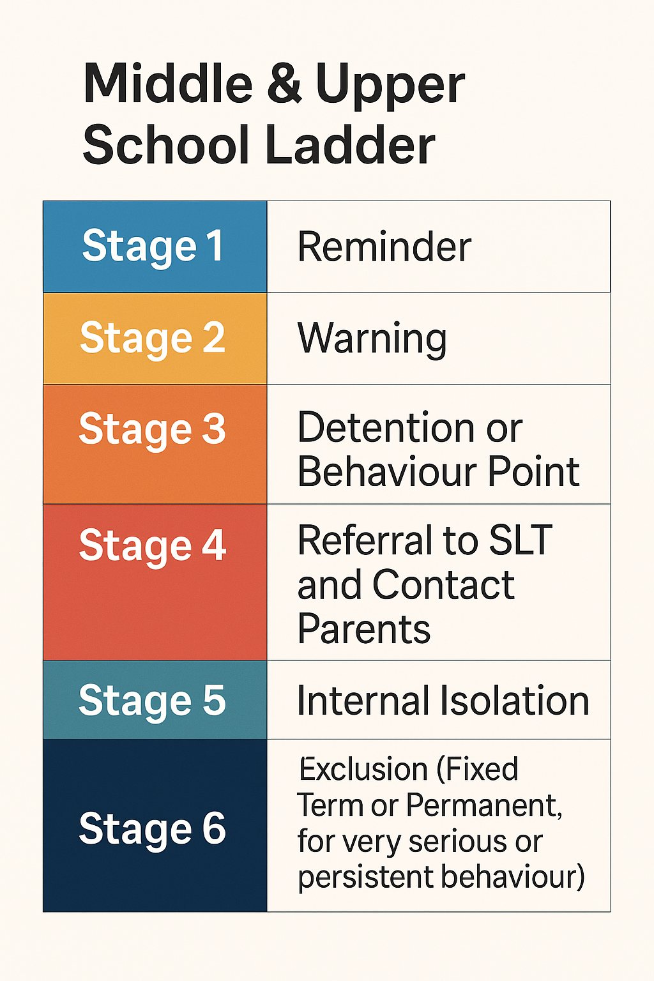

How the Behaviour Ladder Works in Practice
The behaviour ladders are designed to be clear, fair, and consistent. Pupils normally move through the stages step by step within a lesson or breaktime. However, serious behaviour can result in skipping straight to a higher stage.
Progression
- Pupils move up the ladder if behaviour continues after the previous stage.
- Example: off-task talking → Reminder; continues → Warning; continues → Consequence.
- Serious incidents (e.g. fighting, swearing, unsafe behaviour, bullying, discrimination) go straight to Stage 4 or 5.
- Multiple Stage 1 reminders in the same lesson may lead to a Stage 2 warning.
Resets
- The ladder normally resets at the end of a lesson or session, giving pupils a fresh start.
- Each new day begins with a clean slate, reflecting our Christian value of forgiveness.
- However, all Stage 3 and above consequences are recorded.
- If a pupil repeatedly reaches Stage 3 across a week, SLT may arrange a parent meeting or place the pupil on report.
Rationale
This approach ensures that pupils have the chance to put things right each lesson, while patterns of poor behaviour are still tracked and addressed fairly.

Restorative Approach
We believe consequences should help pupils learn. After a sanction, staff hold a short restorative conversation:
1. What happened?
2. Who was affected?
3. How can you put it right?
4. What will you do differently next time?
This helps pupils take responsibility and repair relationships.

Supporting Pupils with SEND
We know that behaviour may be linked to special educational needs or disabilities. Staff will:
- Make reasonable adjustments (extra time, visual prompts, movement breaks)
- Use the Zones of Regulation where appropriate
- Involve the SENCO in planning strategies
- Seek advice from outside professionals if needed
We aim to make behaviour management fair and accessible for all pupils.
Managing Routine Issues: Lateness, Homework, Equipment, and Uniform
Some issues are not disruptive in the same way as poor behaviour in class, but still need consistent management. To keep things fair across the school, the following approach is used for lateness, homework, PE kit/equipment, and uniform.
Lateness
We understand that we have families that travel a distance to attend school, so a common-sense approach will be applied.
- Occasional lateness with a genuine reason → reminder and logged.
- Repeated lateness (3 times in a half-term) → Stage 3 consequence (after school detention or loss of privilege).
- Persistent lateness → SLT informed, parents contacted, and support plan agreed.
Homework not completed
- First time → reminder and expectation to complete by next day.
- Second time → warning + short catch-up session.
- Third time in a half-term → Stage 3 consequence (detention / after-school catch-up).
- Persistent → SLT involvement, parents contacted, and the pupil will have to stay at school for homework club .
Forgotten PE kit or equipment
- First time → reminder, spare kit used if available.
- Second time → warning and logged.
- Third time in a half-term → Stage 3 consequence (detention / written task in place of PE).
- Persistent → SLT involvement, parents contacted, and support plan agreed (e.g. kit kept in school).
Incorrect uniform
- First time → reminder; pupil expected to correct immediately if possible
- Second time → warning and uniform note recorded / sent home.
- Third time in a half-term → Stage 3 consequence (loss of privilege, detention, or lunchtime catch-up).
- Persistent → SLT involvement and parent meeting. Pupil may be placed on daily uniform check/report.
- Financial hardship → school will support families discreetly (e.g. with spare or second-hand uniform) rather than sanction.

Rationale
This approach distinguishes between one-off mistakes (where forgiveness and grace are shown) and persistent patterns (where accountability and consequences are needed). It ensures that all staff apply the same process, so pupils experience consistency across the school.

Working with Parents
Parents are partners in behaviour support. Staff will contact parents if:
- A pupil reaches Stage 3 repeatedly
- There is a serious incident
- An ongoing behaviour concern requires a plan
Parent communication may be by note, email, phone call, or meeting. We believe behaviour is best improved when home and school work together.

Recording and Monitoring
Stage 3 incidents and above are recorded by staff. Senior Leaders review behaviour logs each half term to identify patterns by pupil, class, or type of incident. Serious incidents are logged separately and reported to governors where appropriate. Data is used to support pupils and improve school systems.

Safeguarding and Exclusions
Bullying, discrimination, and abuse are safeguarding concerns. These are dealt with under the Safeguarding Policy. Where behaviour poses a risk, physical restraint may be used but only to prevent harm, in line with the Restraint Policy.
The Headteacher may issue fixed-term or permanent exclusions for very serious or persistent misbehaviour, following DfE statutory guidance.

7.5 Reasonable force
Reasonable force covers a range of interventions that involve physical contact with pupils. All members of staff have a duty to use reasonable force, in the following circumstances, to prevent a pupil from:
- Causing disorder
- Hurting themselves or others
- Damaging property
- Committing an offence
Incidents of reasonable force must:
- Always be used as a last resort
- Be applied using the minimum amount of force and for the minimum amount of time possible
- Be used in a way that maintains the safety and dignity of all concerned
- Never be used as a form of punishment
- Be recorded and reported to parents/carers
When considering using reasonable force, staff should, in considering the risks, carefully recognise any specific vulnerabilities of the pupil, including SEND, mental health needs or medical conditions.
7.6 Confiscation and searching
Searching, screening and confiscation is conducted in line with the DfE’s latest guidance on searching, screening and confiscation.
Confiscation
Any prohibited items (listed in section 3) found in a pupil’s possession as a result of a search will be confiscated. These items will not be returned to the pupil.
We will also confiscate any item that is harmful or detrimental to school discipline. These items will be returned to pupils after discussion with senior leaders and parents/carers, if appropriate.
Searching a pupil
Searches will only be carried out by a member of staff who has been authorised to do so by the headteacher, or by the headteacher themselves.
Subject to the exception below, the authorised member of staff carrying out the search will be of the same sex as the pupil, and there will be another member of staff present as a witness to the search.
An authorised member of staff of a different sex to the pupil can carry out a search without another member of staff as a witness if:
- The authorised member of staff carrying out the search reasonably believes there is risk that serious harm will be caused to a person if the search is not carried out as a matter of urgency; and
- In the time available, it is not reasonably practicable for the search to be carried out by a member of staff who is the same sex as the pupil; or
- It is not reasonably practicable for the search to be carried out in the presence of another member of staff
When an authorised member of staff conducts a search without a witness, they should immediately report this to another member of staff, and make sure a written record of the search is kept.
If the authorised member of staff considers a search to be necessary, but is not required urgently, they will seek the advice of the headteacher, designated safeguarding lead (or deputy) or pastoral member of staff who may have more information about the pupil. During this time the pupil will be supervised and kept away from other pupils.
A search can be carried out if the authorised member of staff has reasonable grounds for suspecting that the pupil is in possession of a prohibited item or any item identified in the school rules for which a search can be made, or if the pupil has agreed.
An appropriate location for the search will be found. Where possible, this will be away from other pupils. The search will only take place on the school premises or where the member of staff has lawful control or charge of the pupil, for example on a school trip.
Before carrying out a search the authorised member of staff will:
- Assess whether there is an urgent need for a search
- Assess whether not doing the search would put other pupils or staff at risk
- Consider whether the search would pose a safeguarding risk to the pupil
- Explain to the pupil why they are being searched
- Explain to the pupil what a search entails – e.g. “I will ask you to turn out your pockets and remove your scarf”
- Explain how and where the search will be carried out
- Give the pupil the opportunity to ask questions
- Seek the pupil’s co-operation
If the pupil refuses to agree to a search, the member of staff can give an appropriate behaviour sanction.
If they still refuse to co-operate, the member of staff will contact the designated safeguarding lead (or deputy), to try to determine why the pupil is refusing to comply.
The authorised member of staff will then decide whether to use reasonable force to search the pupil. This decision will be made on a case-by-case basis, taking into consideration whether conducting the search will prevent the pupil harming themselves or others, damaging property or causing disorder.
The authorised member of staff can use reasonable force to search for any prohibited items identified in section 3, but not to search for items that are only identified in the school rules.
The authorised member of staff may use a metal detector to assist with the search.
An authorised member of staff may search a pupil’s outer clothing, pockets, possessions, desk or locker.
‘Outer clothing’ includes:
- Any item of clothing that isn't worn wholly next to the skin or immediately over underwear (e.g. a jumper or jacket being worn over a t-shirt)
- Hats, scarves, gloves, shoes or boots
Searching pupils’ possessions
Possessions means any items that the pupil has or appears to have control of, including:
- Desks
- Lockers
- Bags
A pupil’s possessions can be searched for any item if the pupil agrees to the search. If the pupil does not agree to the search, staff can still carry out a search for prohibited items (listed in section 3) and items identified in the school rules.
An authorised member of staff can search a pupil’s possessions when the pupil and another member of staff are present.
If there is a serious risk of harm if the search is not conducted immediately, or it is not reasonably practicable to summon another member of staff, the search can be carried out by a single authorised member of staff.
Informing the designated safeguarding lead (DSL)
The staff member who carried out the search should inform the DSL without delay:
- Of any incidents where the member of staff had reasonable grounds to suspect a pupil was in possession of a prohibited item as listed in section 3
- If they believe that a search has revealed a safeguarding risk
All searches for prohibited items (listed in section 3), including incidents where no items were found, will be recorded in the school’s safeguarding system.
Informing parents/carers
Parents/carers will always be informed of any search for a prohibited item (listed in section 3). A member of staff will tell the parents/carers as soon as is reasonably practicable:
- What happened
- What was found, if anything
- What has been confiscated, if anything
- What action the school has taken, including any sanctions that have been applied to their child
Support after a search
Irrespective of whether any items are found as the result of any search, the school will consider whether the pupil may be suffering or likely to suffer harm and whether any specific support is needed (due to the reasons for the search, the search itself, or the outcome of the search).
If this is the case, staff will follow the school’s safeguarding policy and speak to the designated safeguarding lead (DSL). The DSL will consider whether pastoral support, an early help intervention or a referral to children’s social care is appropriate.
Strip searches
The authorised member of staff’s power to search outlined above does not enable them to conduct a strip search (removing more than the outer clothing) and strip searches on school premises shall only be carried out by police officers in accordance with the Police and Criminal Evidence Act 1984 (PACE) Code C.
Before calling the police into school, staff will assess and balance the risk of a potential strip search on the pupil’s mental and physical wellbeing and the risk of not recovering the suspected item.
Staff will consider whether introducing the potential for a strip search through police involvement is absolutely necessary, and will always ensure that other appropriate, less invasive approaches have been exhausted first.
Once the police are on school premises, the decision on whether to conduct a strip search lies solely with them. The school will advocate for the safety and wellbeing of the pupil(s) involved. Staff retain a duty of care to the pupil involved and should advocate for pupil wellbeing at all times.
Communication and record-keeping
Where reasonably possible and unless there is an immediate risk of harm, before the strip search takes place, staff will contact at least 1 of the pupil’s parents/carers to inform them that the police are going to strip search the pupil, and ask them if they would like to come into school to act as the pupil’s appropriate adult. If the school can’t get in touch with the parents/carers, or they aren’t able to come into school to act as the appropriate adult, a member of staff can act as the appropriate adult (see below for information about the role of the appropriate adult).
The pupil’s parents/carers will always be informed by a staff member once a strip search has taken place. The school will keep records of strip searches that have been conducted on school premises, and monitor them for any trends that emerge.
Who will be present
For any strip search that involves exposure of intimate body parts, there will be at least 2 people present other than the pupil, except in urgent cases where there is risk of serious harm to the pupil or others.
One of these must be the appropriate adult, except if:
- The pupil explicitly states in the presence of an appropriate adult that they do not want an appropriate adult to be present during the search, and
- The appropriate adult agrees
If this is the case, a record will be made of the pupil’s decision and it will be signed by the appropriate adult.
No more than 2 people other than the pupil and appropriate adult will be present, except in the most exceptional circumstances.
The appropriate adult will:
- Act to safeguard the rights, entitlements and welfare of the pupil
- Not be a police officer or otherwise associated with the police
- Not be the headteacher
- Be of the same sex as the pupil, unless the pupil specifically requests an adult who is not of the same sex
Except for an appropriate adult of a different sex if the pupil specifically requests it, no one of a different sex will be permitted to be present and the search will not be carried out anywhere where the pupil could be seen by anyone else.
Care after a strip search

After any strip search, the pupil will be given appropriate support, irrespective of whether any suspected item is found. The pupil will also be given the opportunity to express their views about the strip search and the events surrounding it.
As with other searches, the school will consider whether the pupil may be suffering or likely to suffer harm and whether any further specific support is needed (due to the reasons for the search, the search itself, or the outcome of the search).
Staff will follow the school’s safeguarding policy and speak to the designated safeguarding lead (DSL). The DSL will consider if, in addition to pastoral support, an early help intervention or a referral to children’s social care is appropriate.
Any pupil(s) who have been strip searched more than once and/or groups of pupils who may be more likely to be subject to strip searching will be given particular consideration, and staff will consider any preventative approaches that can be taken.

Off-site misbehaviour
Sanctions may be applied where a pupil has misbehaved off-site when representing the school. This means misbehaviour when the pupil is:
- Taking part in any school-organised or school-related activity (e.g. school trips)
- Travelling to or from school
- Wearing school uniform
- In any other way identifiable as a pupil of our school
Sanctions may also be applied where a pupil has misbehaved off-site, at any time, whether or not the conditions above apply, if the misbehaviour:
- Could have repercussions for the orderly running of the school
- Poses a threat to another pupil
- Could adversely affect the reputation of the school
Sanctions will only be given out on school premises or elsewhere when the pupil is under the lawful control of a staff member (e.g. on a school-organised trip).
Online misbehaviour
The school can issue behaviour sanctions to pupils for online misbehaviour when:
- It poses a threat or causes harm to another pupil
- It could have repercussions for the orderly running of the school
- It adversely affects the reputation of the school
- The pupil is identifiable as a member of the school
Sanctions will only be given out on school premises or elsewhere when the pupil is under the lawful control of a staff member.
Suspected criminal behaviour
If a pupil is suspected of criminal behaviour, the school will make an initial assessment of whether to report the incident to the police.
When establishing the facts, the school will endeavour to preserve any relevant evidence to hand over to the police.
If a decision is made to report the matter to the police, the headteacher will make the report.
The school will not interfere with any police action taken. However, the school may continue to follow its own investigation procedure and enforce sanctions, as long as it does not conflict with police action.
If a report to the police is made, the designated safeguarding lead (DSL) will make a tandem report to children’s social care, if appropriate.
Zero-tolerance approach to sexual harassment and sexual violence
The school will ensure that all incidents of sexual harassment and/or violence are met with a suitable response, and never ignored.
Pupils are encouraged to report anything that makes them uncomfortable, no matter how ‘small’ they feel it might be.
The school’s response will be:
- Proportionate
- Considered
- Supportive
- Decided on a case-by-case basis
The school has procedures in place to respond to any allegations or concerns regarding a child’s safety or wellbeing. These include clear processes for:
- Responding to a report
- Carrying out risk assessments, where appropriate, to help determine whether to:
  - Manage the incident internally
  - Refer to early help
  - Refer to children’s social care
  - Report to the police
Please refer to our child protection and safeguarding policy for more information
Malicious allegations
Where a pupil makes an allegation against a member of staff and that allegation is shown to have been deliberately invented or malicious, the school will consider whether to discipline the pupil in accordance with this policy.
Where a pupil makes an allegation of sexual violence or sexual harassment against another pupil and that allegation is shown to have been deliberately invented or malicious, the school will consider whether to discipline the pupil in accordance with this policy.
In all cases where an allegation is determined to be unsubstantiated, unfounded, false or malicious, the school (in collaboration with the local authority designated officer (LADO), where relevant) will consider whether the pupil who made the allegation is in need of help, or the allegation may have been a cry for help. If so, a referral to children’s social care may be appropriate.
The school will also consider the pastoral needs of staff and pupils accused of misconduct.
Please refer to our child protection and safeguarding policy and allegations against staff for more information on responding to allegations of abuse against staff or other pupils.
Damage/Loss to property
A charge will be levied in respect of wilful damage, neglect or loss of schools property (including but not limited to premises, furniture, equipment, books or materials), the charge to be the cost of replacement or repair, or such lower cost as the Head teacher may decide.
A charge will be levied in respect of wilful damage, neglect or loss of another students’ property (including but not limited to uniform, equipment, books or materials), the charge to be the cost of replacement or repair, or such lower cost as the Head teacher may decide.
Failure to pay may mean that the student is not allowed to go on future school trips and/or GCSE certificates are withheld until the account is settled.

Monitoring and Review
This policy will be reviewed annually by SLT and governors, or sooner if needed. Feedback from pupils, staff and parents will inform revisions. Behaviour data is reported termly to governors.

Links with other policies
This behaviour policy is linked to the following policies:
- Child protection and safeguarding policy
- Physical restraint policy (appendix 5)
- Mobile phone policy

Appendix 1: written statement of behaviour principles
- Every pupil understands they have the right to feel safe, valued and respected, and to be able to learn free from the disruption of others
- All pupils, staff and visitors are free from any form of discrimination
- Staff and volunteers set an excellent example to pupils at all times
- Rewards, sanctions and reasonable force are used consistently by staff, in line with the behaviour policy
- The behaviour policy is understood by pupils and staff
- The exclusions policy explains that exclusions will only be used as a last resort, and outlines the processes involved in suspensions and exclusions
- Pupils are helped to take responsibility for their actions
- Families are involved in the handling of behaviour incidents to foster good relationships between the school and pupils’ home life

The governing board also emphasises that violence or threatening behaviour will not be tolerated in any circumstances.

Appendix 2: staff training log

TRAINING RECEIVED | DATE COMPLETED | TRAINER / TRAINING ORGANISATION | TRAINER’S SIGNATURE | STAFF MEMBER’S SIGNATURE | SUGGESTED REVIEW DATE

Appendix 3: letters to parents/carers about pupil behaviour – templates
First behaviour letter
Dear [insert parent/carer name],
I wanted to make you aware of an incident that happened today. [Insert brief description of the behaviour incident]. As you will appreciate, this behaviour doesn’t adhere to our behaviour curriculum, which is set out in our behaviour policy. [You may want to reference the specific part, e.g. ‘treating others fairly’ or ‘respecting other pupils’ property’.]
This has been promptly followed up in school with [insert brief description of what the school has done, e.g. talk with pastoral lead, missed break time].
I am confident that no further action will need to be taken, but would be grateful if you could discuss [insert pupil’s name]’s behaviour with them to ensure a consistent message between school and home.
Please do not hesitate to contact me if you would like to discuss this further.
Yours sincerely,
Class teacher name: _____________________________________________________________________

Class teacher signature: __________________________________________________________________

Date: ________________________

---------------------------------------------------------------------------------------------------------------------------------------------

Behaviour letter – return slip

Please return this slip to school to confirm you have received this letter. Thank you.

Name of child: __________________________________________________________________________

Parent/carer name: _______________________________________________________________________

Parent/carer signature: ____________________________________________________________________

Date: ________________________
Second behaviour letter

Dear [insert parent/carer name],
Following my previous letter regarding the behaviour of [insert pupil name], I am sorry to say that they are still struggling to adhere to our behaviour curriculum, which is set out in our behaviour policy. [Insert brief description of behaviour incident.]
I would appreciate it if you could arrange to meet me after school so we can discuss a way forward.
Insert details of how to contact the school to arrange the meeting.

Yours sincerely,
Class teacher name: _____________________________________________________________________

Class teacher signature: __________________________________________________________________

Date: ______________________

Third behaviour letter

Dear [insert parent/carer name],
I am sorry to let you know that, despite meeting and [insert agreed steps forward from your previous meeting, e.g. creating a behaviour contract], there has been an incident today where [insert brief description of latest behaviour incident]. [Insert pupil’s name] would now benefit from a structured approach to help improve their behaviour in school.
As outlined in our behaviour policy, I would be grateful if you could attend a meeting with [insert who will be at the meeting, e.g. the headteacher, the special educational needs co-ordinator, pastoral lead], to discuss the further support we will be putting in place for [insert pupil’s name].
[Insert details of the meeting time, date and location, as necessary, or how to contact the school to arrange the meeting.]

Yours sincerely,

Class teacher name: _____________________________________________________________________

Class teacher signature: __________________________________________________________________

Date: _______________________

Detention letter

Dear parent/carer,
I am writing to inform you that [insert pupil’s name] has been given a detention on [insert date] at [insert time].
The reason(s) for this detention are set out below.
Insert a brief description of the behaviour incident that led to the detention here.

If you would like to discuss this incident, please call the school to make an appointment.

Yours sincerely,

Class teacher name: _____________________________________________________________________

Class teacher signature: __________________________________________________________________

Date: _______________________

------------------------------------------------------------------------------------------------------------------------------------------------

Detention letter – return slip

Please return this slip to school to confirm you have received this letter. Thank you.

Name of child: ___________________________________________________________________

Parent/carer name: ____________________________________________________________________

Parent/carer signature: _________________________________________________________________

Date: ____________________

Appendix 5: Physical restraint policy

Contents
- Introduction 4
- Other Policies 4
- Rationale 4
- What is reasonable force? 4
- Minimising the need to use reasonable force 5
- When can reasonable force be used? 6
- Deciding whether to use reasonable force 7
- Using reasonable force 7
- Power to search pupils without consent 8
- Staff Training 8
- Recording/reporting Incidents 9
Introduction

Guidance concerning the use of reasonable force to restrain pupils can be found in section 550(A) of the Education Act 1996, as inserted by section 4 of the Education Act 1997. This provision was extended to include all schools by section 131 of the School Standards and Framework Act 1998.
This policy should be read in conjunction with the Use of Reasonable Force (July 2013) DfE Guidance document for headteachers, staff and governing bodies.

Other Policies

Other policies to be read in conjunction with this policy:

- Behaviour policy
- Health & Safety
- Safeguarding (Child Protection)
- Special Educational Needs (in progress)

Rationale

  - The Education Act 1996 forbids corporal punishment, but allows all teachers to use reasonable force to prevent a pupil from:
    - committing a criminal offence
    - injuring themselves or others
    - damaging property
    - acting in a way that is counter to maintaining good order and discipline at the school
  - This power may be used where the student (including students from other schools) is on the school premises or elsewhere in the lawful control or in the charge of a staff member.

  - There is no legal definition of when it is reasonable to use force. That will always depend on the precise circumstances of individual cases. To be judged lawful, the force used would need to be in proportion to the consequences it is intended to prevent. The degree of force used should always be the minimum needed to achieve the desired result.

  - The Act does not cover more extreme situations, such as action in self‐defence or in an
emergency, when it might be reasonable for someone to use a degree of force.

What is reasonable force?

  - The term ‘reasonable force’ covers the broad range of actions used by most teachers at some point in their career that involve a degree of physical contact with pupils.

  - Force is usually used either to control or restrain. This can range from guiding a pupil to safety by the arm through to more extreme circumstances such as breaking up a fight or where a student needs to be restrained to prevent violence or injury.

  - ‘Reasonable in the circumstances’ means using no more force than is needed.

  - As mentioned above, schools generally use force to control pupils and to restrain them. Control means either passive physical contact, such as standing between pupils or blocking a pupil's path, or active physical contact such as leading a pupil by the arm out of a classroom.

  - Restraint means to hold back physically or to bring a pupil under control. It is typically used in more extreme circumstances, for example when two pupils are fighting and refuse to separate without physical intervention.

  - School staff should always try to avoid acting in a way that might cause injury, but in extreme cases it may not always be possible to avoid injuring the pupil.

Minimising the need to use reasonable force

  - Staff should always try to deal with the situation using other agreed strategies to calm a situation before considering using force.

  - Although the school recognises that preventative measures will not always work, there are numerous steps that will be taken in order to help reduce the likelihood of situations arising where the power to use force may need to be exercised. We endeavour to:
    - Create a calm, orderly and supportive school environment that minimises the risk of violence of any kind
    - Develop effective relationships between students and staff that are central to good order
    - Adopt a whole‐school approach to developing social and emotional skills using zones of regulation
    - Take a structured approach to staff development that helps staff to develop the skills of positive behaviour management; managing conflict and also support each other during and after an incident
    - Recognise that challenging behaviours are often foreseeable
    - Effectively manage individual incidents while understanding the importance of
communicating calmly with the student, using non‐ threatening verbal body language and ensuring that the student can see a way out of a situation. For example, students should always be given an option of going to a quiet space with the staff member away from bystanders and other students, so that the staff member can listen to concerns; or being joined by a particular member of staff well known to the pupil
    - Wherever practical, warning a student that force may have to be used before using force.

Staff authorised to use reasonable force

The staff to which this power applies are defined in Section 93 of the Education and Inspections Act 2006. These are:

- All members of school staff have a legal power to use reasonable force.
- This power applies to any member of staff at the school. It can also apply to people whom the headteacher has temporarily put in charge of pupils such as unpaid volunteers or parents accompanying students on a school organised visit.

When can reasonable force be used?

  - Reasonable force can be used to prevent pupils from hurting themselves or others, from damaging property, or from causing disorder.

  - In a school, force is used for two main purposes – to control pupils or to restrain them.

  - The decision on whether or not to physically intervene is down to the professional judgement of the staff member concerned and should always depend on the individual circumstances.

  - The following list is not exhaustive but provides some examples of situations where reasonable force can and cannot be used.

  - Schools can use reasonable force to:
    - remove disruptive children from the classroom where they have refused to follow an instruction to do so;
    - prevent a pupil behaving in a way that disrupts a school event or a school trip or visit;
    - prevent a pupil leaving the classroom where allowing the pupil to leave would risk their safety or lead to behaviour that disrupts the behaviour of others;
    - prevent a pupil from attacking a member of staff or another pupil, or to stop a fight in the playground; and
    - restrain a pupil at risk of harming themselves through physical outbursts.
  - Schools cannot:
    - use force as a punishment – it is always unlawful to use force as a punishment.
  - In these examples use of force would be reasonable (and therefore lawful) if it was clear that the behaviour was sufficiently dangerous or disruptive to warrant physical intervention of the degree applied and could not be realistically dealt with by any other means.

Deciding whether to use reasonable force

  - Staff should only use force when the risk of not using force significantly outweighs those of using force. Then the judgement whether to use force and what force to use should always depend on the circumstances of each case. Students with SEN and/or disabilities should be handled according to information about the individual student concerned

  - Decisions on whether the precise circumstances of an incident justify the use of significant force must be reasonable. Typically, such decisions have to be made quickly, with little time for reflection. Nevertheless, staff need to make the clearest possible judgements about:
    - The seriousness of the incident, assessed by the effect of the injury, damage or disorder which is likely to result if force is not used.
    - The greater the potential for injury, damage or serious disorder, the more likely it is that using force may be justified
    - The chances of achieving the desired result by other means. The lower the probability of achieving the desired result by other means the more likely it is that using force can be justified.
    - The relative risks associated with the physical intervention compared to the risks of using other strategies. The smaller the risks associated with physical intervention compared with other strategies, the more likely it is that using force can be justified

Using reasonable force

  - Staff, as far as possible, should not use force unless or until another responsible adult is present to support, observe and call for assistance. Then staff should always only use the minimum amount of force to achieve the desired effect.

  - Before using reasonable force, staff should, wherever practical tell the pupil to stop misbehaving and communicate in a calm measured manner throughout the incident. Staff should not give the impression of acting out of anger or frustration, or to punish a pupil, and should make it clear that physical contact or restraint will stop as soon as it ceases to be necessary.

  - Types of reasonable force used could include:
    - Passive physical contact resulting from standing between students or staff and students
    - Active physical contact such as leading a pupil by the arm or hand or ushering a pupil away by placing a hand in the centre of the back
    - In more extreme circumstances, using appropriate restrictive holds
  - Where there is a high and immediate risk of death or of serious injury, any member of staff would be justified in taking necessary action (consistent with the principle of seeking to use the minimum force required to achieve the desired result). Such situations could include

preventing a student running off the pavement onto a busy road or preventing a student hitting someone with a dangerous object such as a glass bottle or hammer.

  - Staff should always make every effort to avoid acting in a way that might reasonably be expected to cause injury. However, in the most extreme circumstances it may not always be possible to avoid injuring a student.

  - Staff should always avoid touching or restraining a student in a way that could be interpreted as sexually inappropriate.

Power to search pupils without consent

  - In addition to the general power to use reasonable force described above, headteachers and authorised staff can use such force as is reasonable given the circumstances to conduct a search for the following “prohibited items” :
    - knives and weapons
    - alcohol
    - illegal drugs
    - stolen items
    - tobacco and cigarette papers
    - fireworks
    - pornographic images
    - any article that has been or is likely to be used to commit an offence, cause personal injury or damage to property.

  - Force cannot be used to search for items banned under the school rules.

Staff Training

  - The Special Educational Needs Co‐ordinator (SENDco) will also make individual risk assessments available to staff where it is known that force is more likely to be necessary to restrain a particular student, such as a student whose SEN and/or disability is associated with extreme behaviour. Appropriate training will be given to the necessary staff working with these students on a regular basis, and College staff will be notified about procedures inplace.
Recording/reporting Incidents

  - Emmanuel Christian School will keep records of every incident in which force has been used, in accordance with policy and procedures and safeguarding requirements. The purpose of recording is to ensure policy guidelines are followed, to inform parents, to inform governors of improvement processes, to prevent misunderstanding or misinterpretation of the incident and to provide a record for any future enquiry.

  - Staff that can be called if a situation arises include:
    - SENDco
    - SLT Member
    - Head of Lower School
    - Head of Middle School
    - Head of Upper School
    - Headteacher
Staff to be informed If / when restraint takes place:
    - Head of Lower School
    - Head of Middle School
    - Head of Upper School
    - Headteacher
  - Parents/carers to be informed on the same day by:
    - SENCO
    - Head of Lower School
    - Head of Middle School
    - Head of Upper School
    - Headteacher

